* Different Options for the test run:
  + How to run specific test file
  + What is watch Mode?
  + How to run the failed test case.
  + How to run all test cases.
  + How to quit watch mode.
  + How to filter test files for run.
  + How to Filter test case.
* **How to run specific test file**
  + 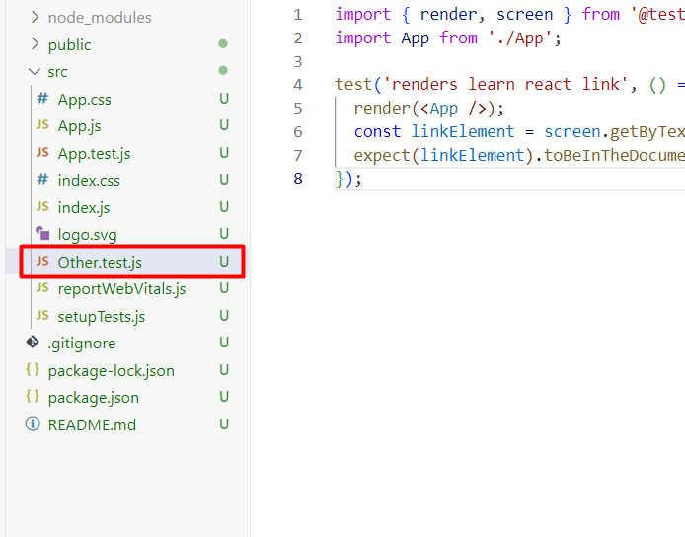
  + Created one more test file as Other.test.js
  + We need to run the command:
    - npm run test Other
    - 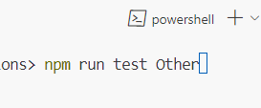
* **What is watch Mode**?
  + When we first run the test then if we make it keep running, then it automatically identifies which file has changed then the watch mode will automatically run the file.
    - 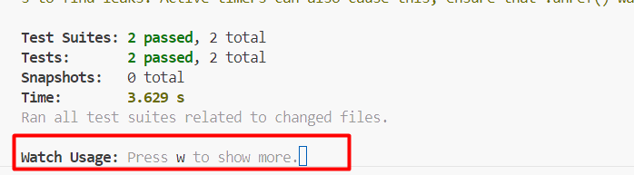
  + After pressing w to show more options then it will display all the available options.
    - 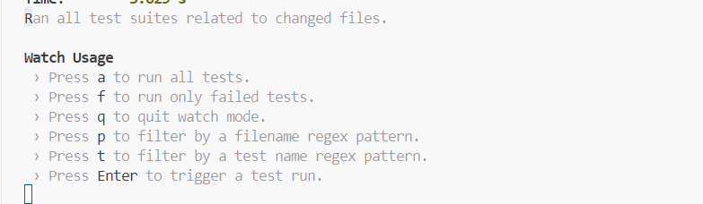
* **How to run the failed test case**.
  + 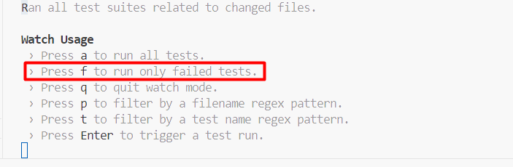
* **How to run all test cases.**
  + 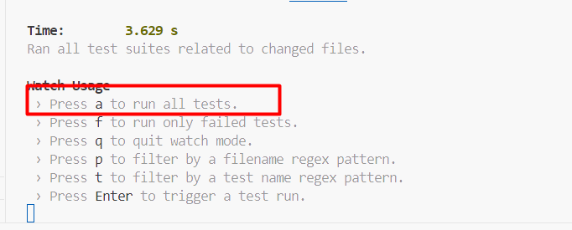
* **How to quit watch mode.**
  + 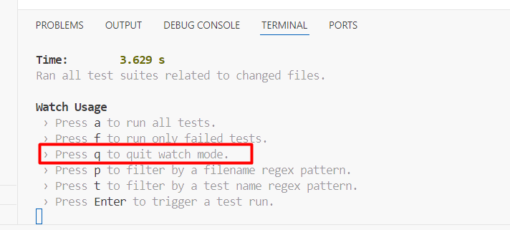
* **How to filter test files for run.**
  + 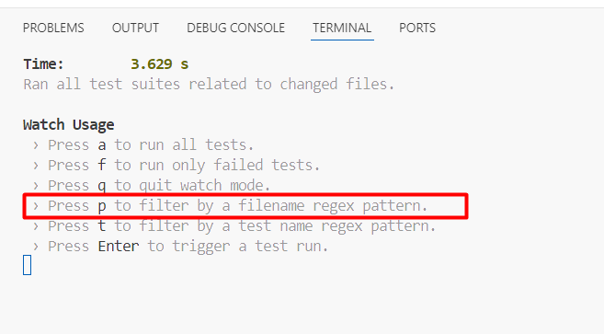
  + We will type the file name starting characters, then it will automatically display the filename
    - 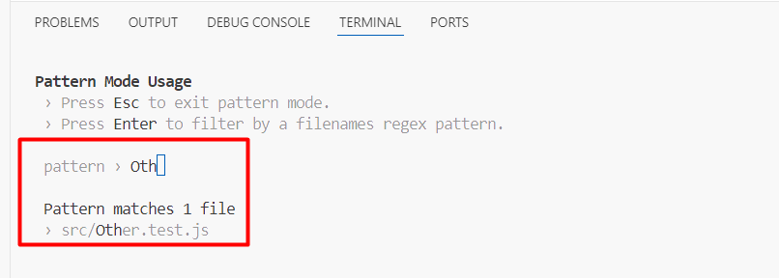
    - 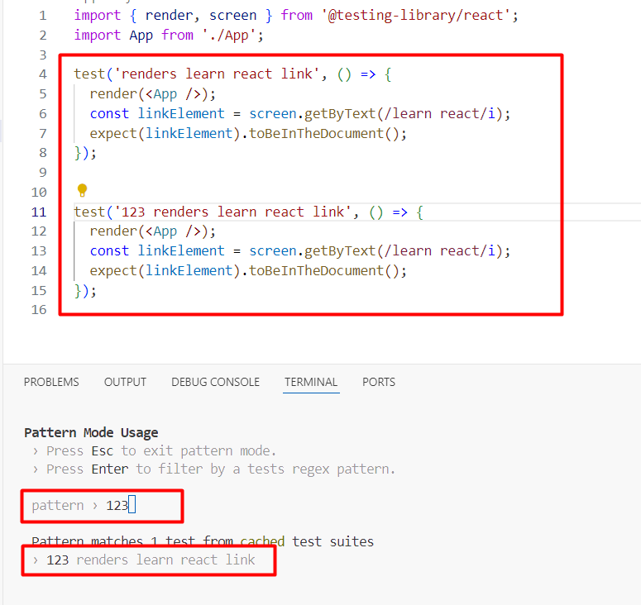
* **How to Filter test case.**
  + 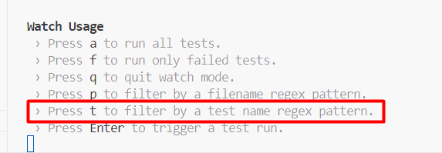
  + We will type the test name starting characters, then it will automatically display the test function to run.
    - 